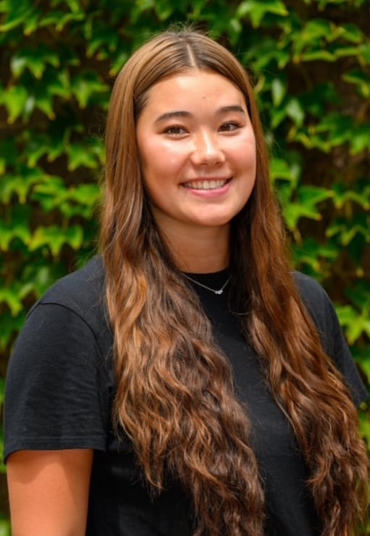
Title: The Benefits of Testosterone Therapy for Menopausal Symptoms

Presenting Author Name: Jillian Chan BS, MS

Co-authors: Julia Cunningham BA, Colin Cunningham BA, John Cunningham MD, Catherine Cunningham MD

Affiliation Co-authors: Catherine Cunningham, Overlook Hospital, Summit NJ USA
Abstract:

Objectives: This study will address the effects of testosterone pellet therapy in menopausal women treated over a ten-year period.

Study Design: A retrospective review of a single gynecologic practice was performed to evaluate patients treated with subcutaneous testosterone pellet therapy for androgen deficiency. Consent was obtained from all patients before pellet placement. Women completed a menopause rating scale (MRS) questionnaire prior to starting therapy and before the third pellet placement. Patients were treated every 3 months. Blood work was obtained prior to treatment, before the third pellet insertion and then yearly. Non-parametric analysis was performed using the Wilcoxon signed-rank test and the Bonferroni test was used to correct for comparisons across multiple domains. A p value of less than 0.05 was considered significant.

Main Outcome Measures: Scores on the MRS were calculated as medians and compared from the initial MRS to the subsequent MRS questionnaire. Patient’s age and peak testosterone levels were used to evaluate the effect of therapy on menopausal symptoms. Side effects from therapy were noted at follow-up visits.

Results: There were 78 patients who completed both MRS questionnaires. A comparison of results from the initial and subsequent MRS questionnaire showed that median scores were significantly reduced in all eleven categories of symptoms. Scores improved in all categories of patient age and peak testosterone levels. The most common side effects were acne and facial hair. These were treated with dose reduction and or spironolactone therap.

Conclusions: The use of testosterone pellet therapy in women with androgen deficiency results in rapid and sustained relief of menopausal symptoms in all age groups and at all testosterone levels. Further studies are needed to optimize the use of testosterone in women with menopausal symptoms.

Biography: Jillian Chan earned her B.S. in Health Sciences from Rider University in 2022 and her M.S. in Integrative Medicine and Health Sciences from Georgetown University in 2024. She has research experience in a human performance laboratory, where she published her first paper examining the long-term cardiovascular implications of COVID-19. Jillian also brings clinical experience from urology and neurology settings and is currently working with Dr. Catherine Cunningham as a medical assistant in her gynecology practice specializing in hormone replacement therapy. She plans to pursue a career in healthcare with a focus on women’s health and reproductive care.

